<https://www.kaggle.com/c/otto-group-product-classification-challenge/data>

Each row corresponds to a single product. There are a total of 93 numerical features, which represent counts of different events. All features have been obfuscated and will not be defined any further.

There are nine categories for all products. Each target category represents one of our most important product categories (like fashion, electronics, etc.). The products for the training and testing sets are selected randomly.

The Otto Group is one of the world’s biggest e-commerce companies, with subsidiaries in more than 20 countries, including Crate & Barrel (USA), Otto.de (Germany) and 3 Suisses (France). We are selling millions of products worldwide every day, with several thousand products being added to our product line.

A consistent analysis of the performance of our products is crucial. However, due to our diverse global infrastructure, many identical products get classified differently. Therefore, the quality of our product analysis depends heavily on the ability to accurately cluster similar products. The better the classification, the more insights we can generate about our product range.

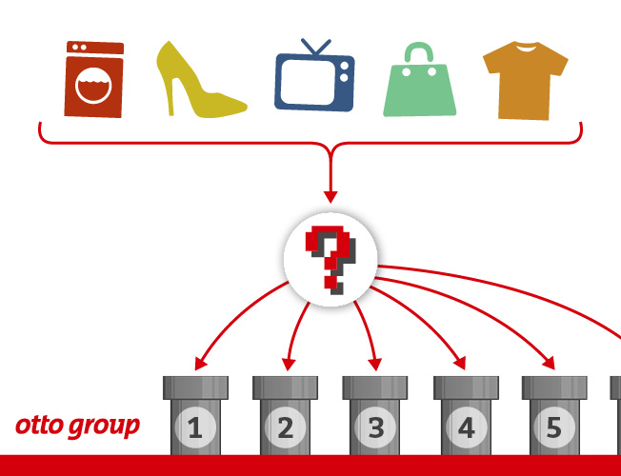

For this competition, we have provided a dataset with 93 features for more than 200,000 products. The objective is to build a predictive model which is able to distinguish between our main product categories. The winning models will be open sourced.